Mane Meals: The Everyday Edition

Welcome to Mane Meals
Eating to support your hair doesn't have to mean buying expensive superfoods, following a strict meal plan, or making something different every day.
Mane Meals: The Everyday Edition brings together 21 meal and snack ideas that provide nutrients important for healthy hair.
You'll find meals for busy mornings, quick lunches, and evenings when you barely feel like cooking. Many use similar ingredients in different ways, giving you more variety without having to start from scratch every day.
The goal isn't to follow every meal exactly. It's to give you ideas you can come back to, adapt, and make your own.

10 Nutrients That Support Healthy Hair
Your hair follicles need a steady supply of energy and nutrients to function properly. These 10 nutrients support different parts of that process, from building hair strands to maintaining healthy cells and scalp tissue.
Protein
Provides the amino acids needed to build keratin, the main protein in hair.
Carbohydrates
Supply energy that helps fuel your body's normal functions, including hair growth.
Iron
Helps carry oxygen throughout the body, including to tissues that support hair growth.
Zinc
Supports cell growth, tissue repair, and normal hair follicle function.
Vitamin D
Plays a role in hair follicle cycling and normal immune function.
Vitamin B12
Supports red blood cell production and DNA synthesis, both important for rapidly dividing cells.
Vitamin C
Supports collagen production and helps your body absorb iron from plant foods.
Biotin
Helps your body metabolize nutrients for energy and supports normal cell function.
Omega-3 Fatty Acids
Provide essential fats used in cell membranes and help regulate inflammatory processes.
Folate
Supports DNA synthesis and cell division, processes needed for normal hair follicle activity.

Make It Work for You
There's no schedule to follow and no particular order to eat these meals.
Choose what fits your day.
Some meals come together in minutes. Others need a little more preparation. Pick what works for your time, appetite, and energy.
Repeat what you enjoy.
You don't need 21 different meals and snacks every week. Find a few favorites and bring them into your regular rotation.
Use what you already have.
Many of these meals share ingredients, so you can use the same foods in different ways. Swap ingredients based on what you have available and what you like.
Make it your own.
These are meal ideas, not strict recipes. Adjust portions, seasonings, and ingredients to suit your needs.
You'll also see the nutrients highlighted under each meal, so you can recognize how everyday foods contribute to nourishing your hair.

THE MANE MEALS
For mornings when you're on the go
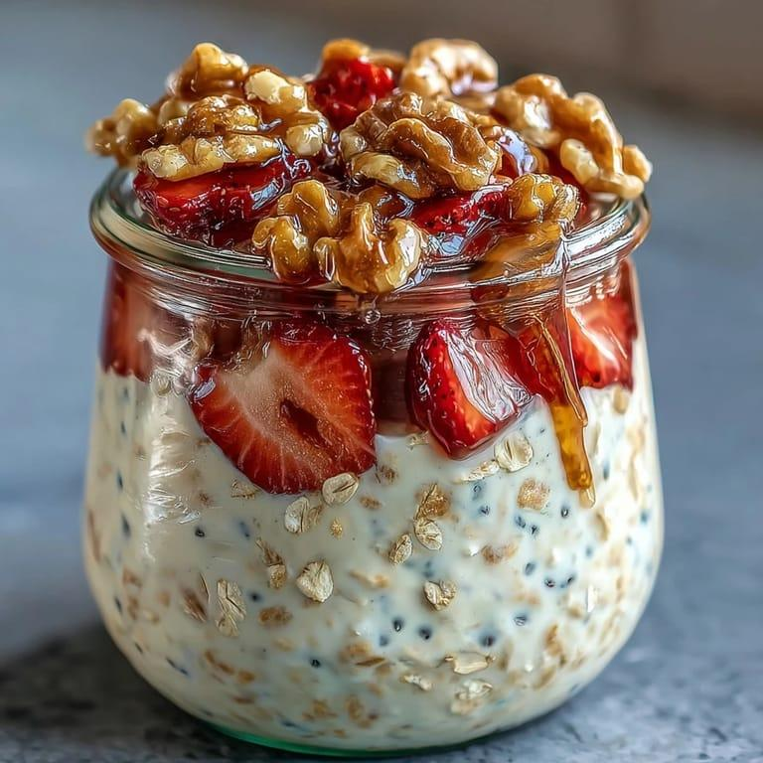
Strawberry Overnight Oats
Oats, Greek yogurt, fortified milk, strawberries, chia seeds and walnuts.
Protein · Carbohydrates · Vitamin D* · Vitamin B12 · Omega-3 (ALA)
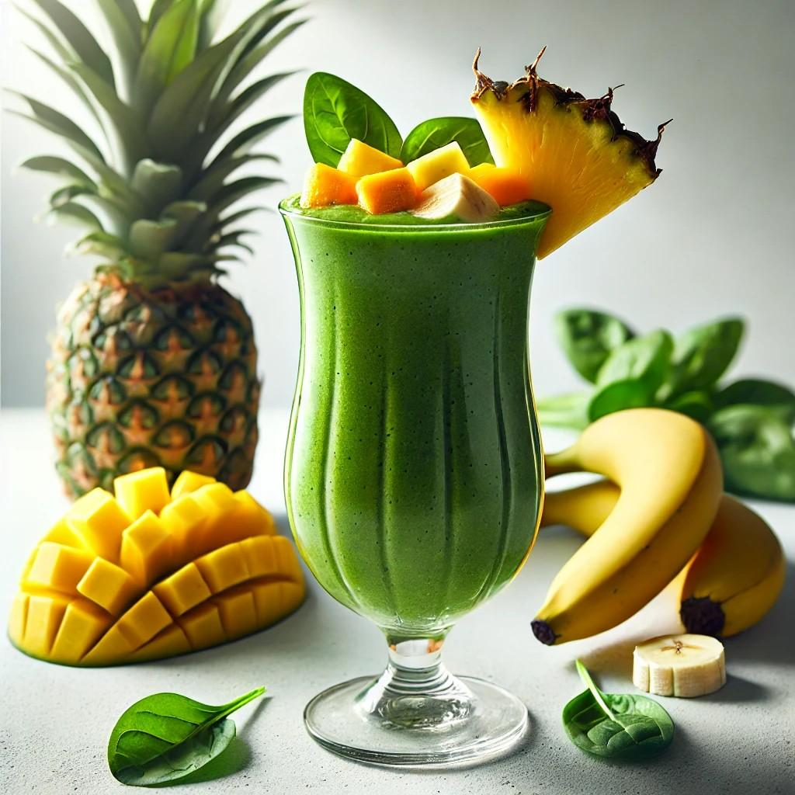
Tropical Green Protein Smoothie
Fortified milk or soy milk, protein powder, frozen mango, pineapple, spinach and ground flaxseed.
Protein · Carbohydrates · Vitamin C · Folate · Omega-3 (ALA) · Vitamin D*
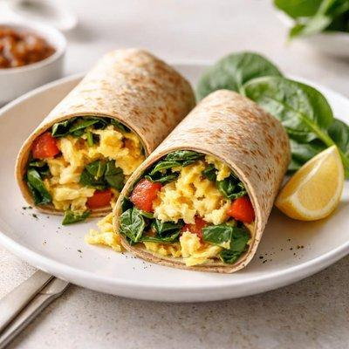
Spinach & Egg Breakfast Burrito
Scrambled eggs, tomatoes, spinach and cheddar cheese in a whole-wheat tortilla, with orange slices or berries.
Protein · Carbohydrates · Biotin · Vitamin B12 · Folate · Vitamin C · Zinc

For mornings when you have a little more time
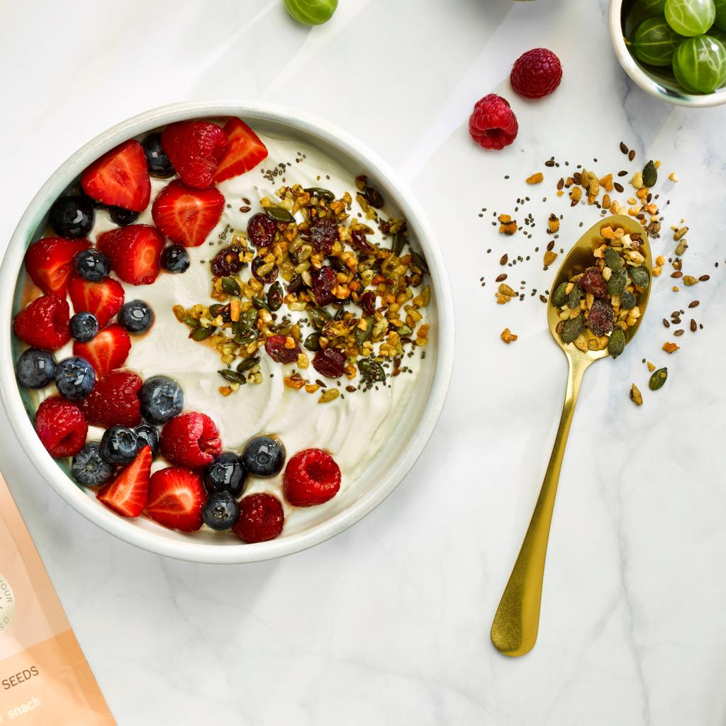
Berry Crunch Yogurt Bowl
Greek yogurt, fresh berries, granola, chia seeds and pumpkin seeds.
Protein · Carbohydrates · Vitamin C · Zinc · Omega-3 (ALA)
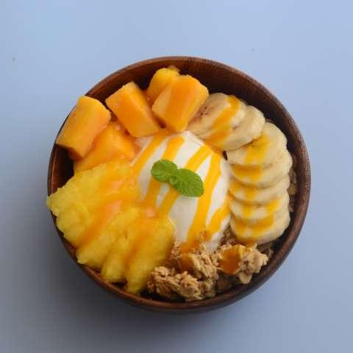
Tropical Yogurt Bowl
Greek yogurt, mango, pineapple, banana, granola and pumpkin seeds.
Protein · Carbohydrates · Vitamin C · Zinc
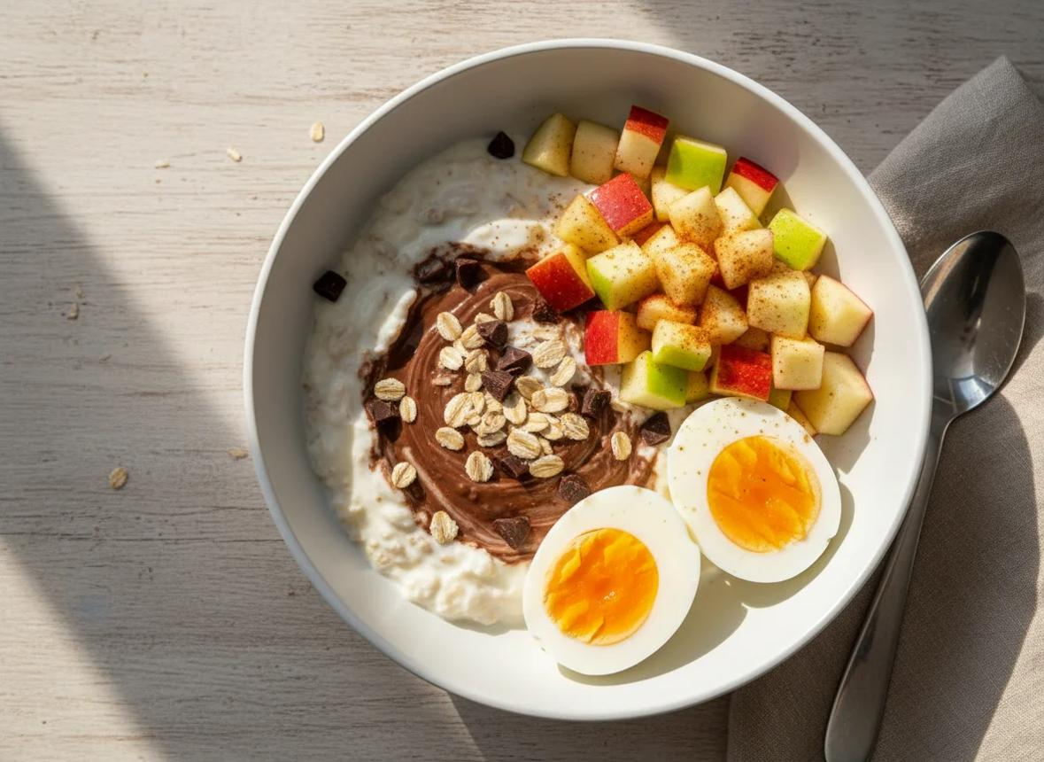
Apple Cinnamon Oats & Eggs
Oatmeal made with fortified milk, diced apple, cinnamon and ground flaxseed, with boiled eggs on the side.
Protein · Carbohydrates · Biotin · Vitamin B12 · Omega-3 (ALA) · Vitamin D*

For when you need a quick lunch
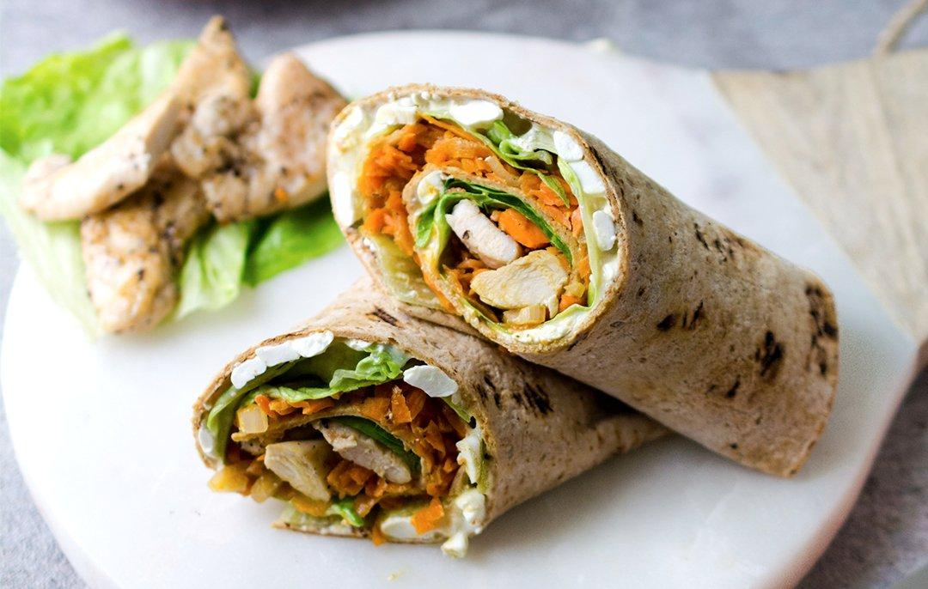

Chicken Crunch Wrap
Precooked chicken, whole-wheat tortilla, lettuce, shredded carrots, feta cheese, and Greek yogurt dressing.
Protein · Carbohydrates · Zinc ·

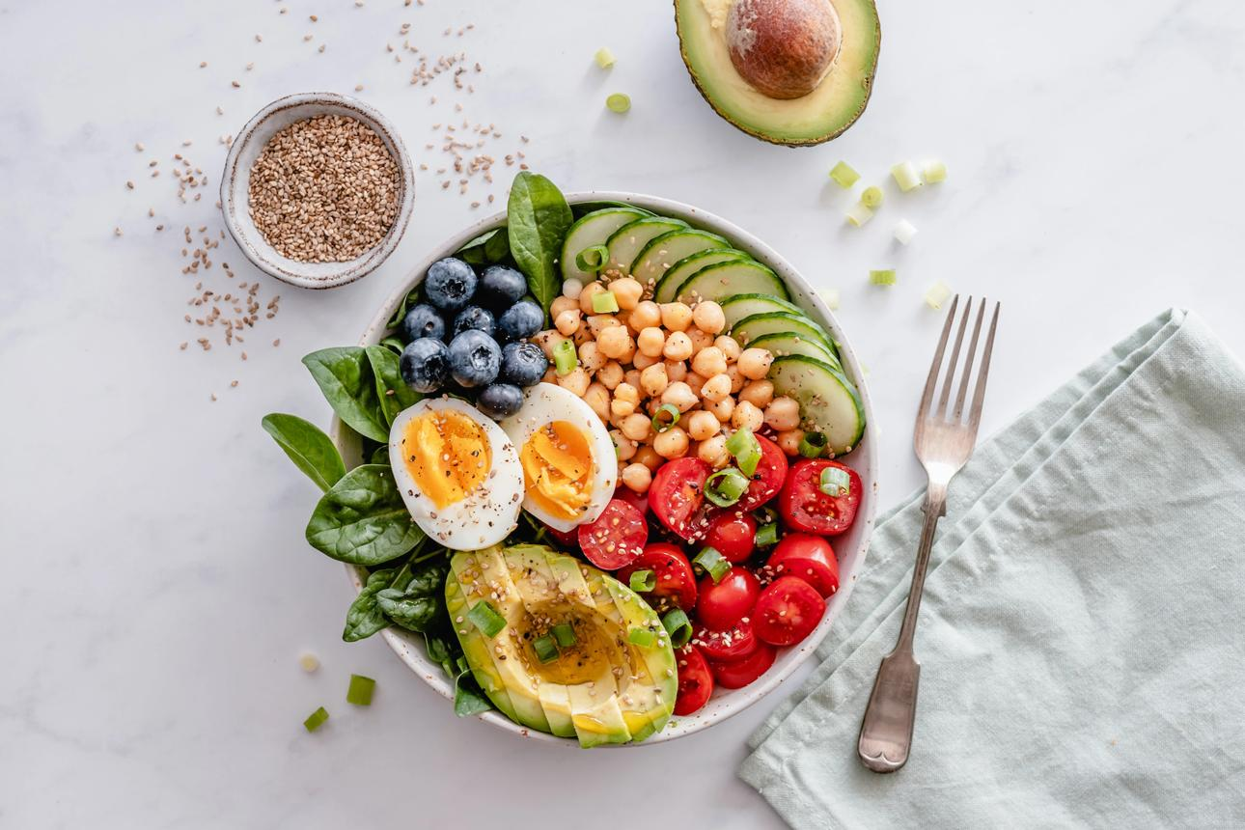
Chickpea & Egg Salad
Chickpeas, boiled eggs, spinach, tomatoes, avocado, cucumbers, blueberries
Protein · Carbohydrates · Iron · Folate · Biotin · Vitamin C
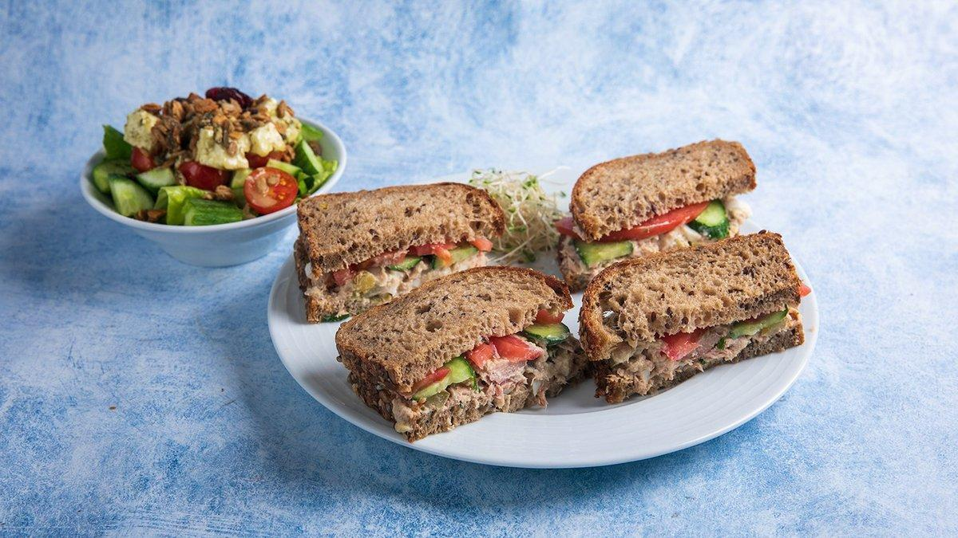
Tuna Salad Sandwich with Tomato, Cucumber & Feta Salad
Canned light tuna, Greek yogurt or mayonnaise, whole-grain bread, tomato, cucumber, feta cheese, olive oil, lemon juice.
Protein · Carbohydrates · Vitamin B12 · Vitamin C

For lunches you want to make ahead of time

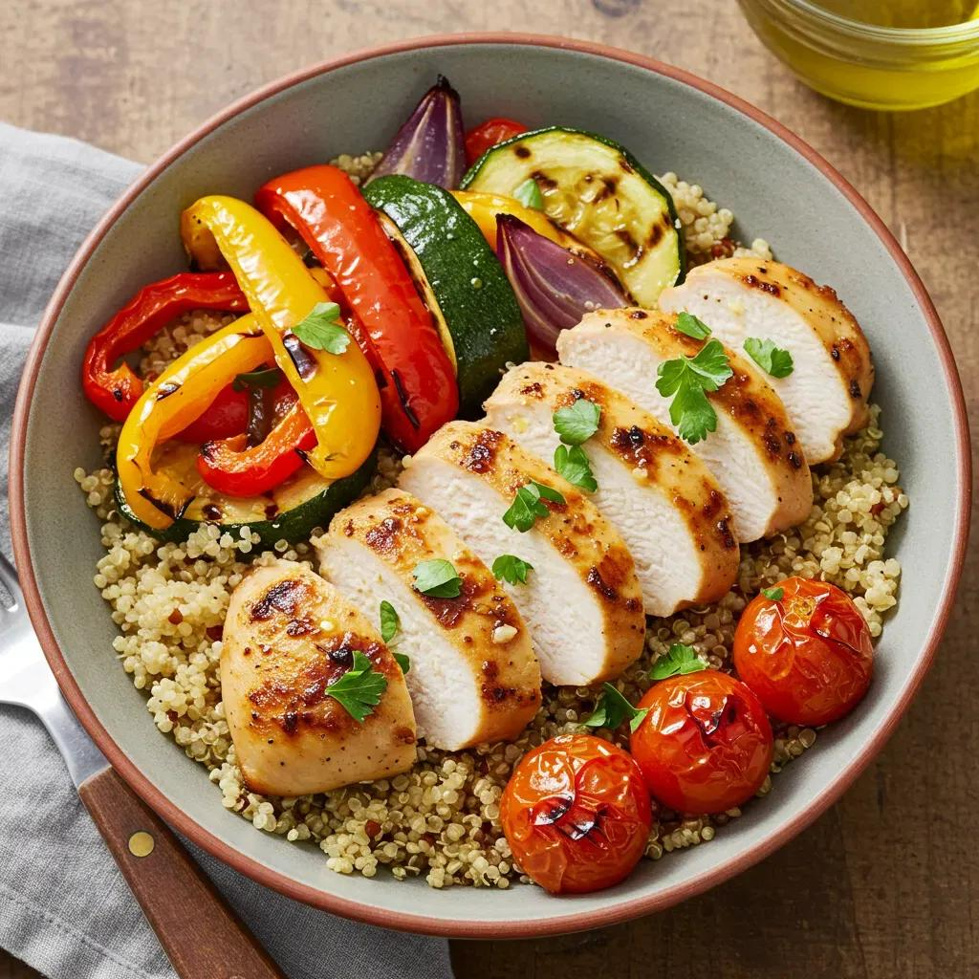
Chicken & Quinoa Veggie Bowl
Chicken, quinoa sautéed with onions and grilled tomatoes, bell peppers and zucchini,
Protein · Carbohydrates · Iron · Folate · Vitamin C
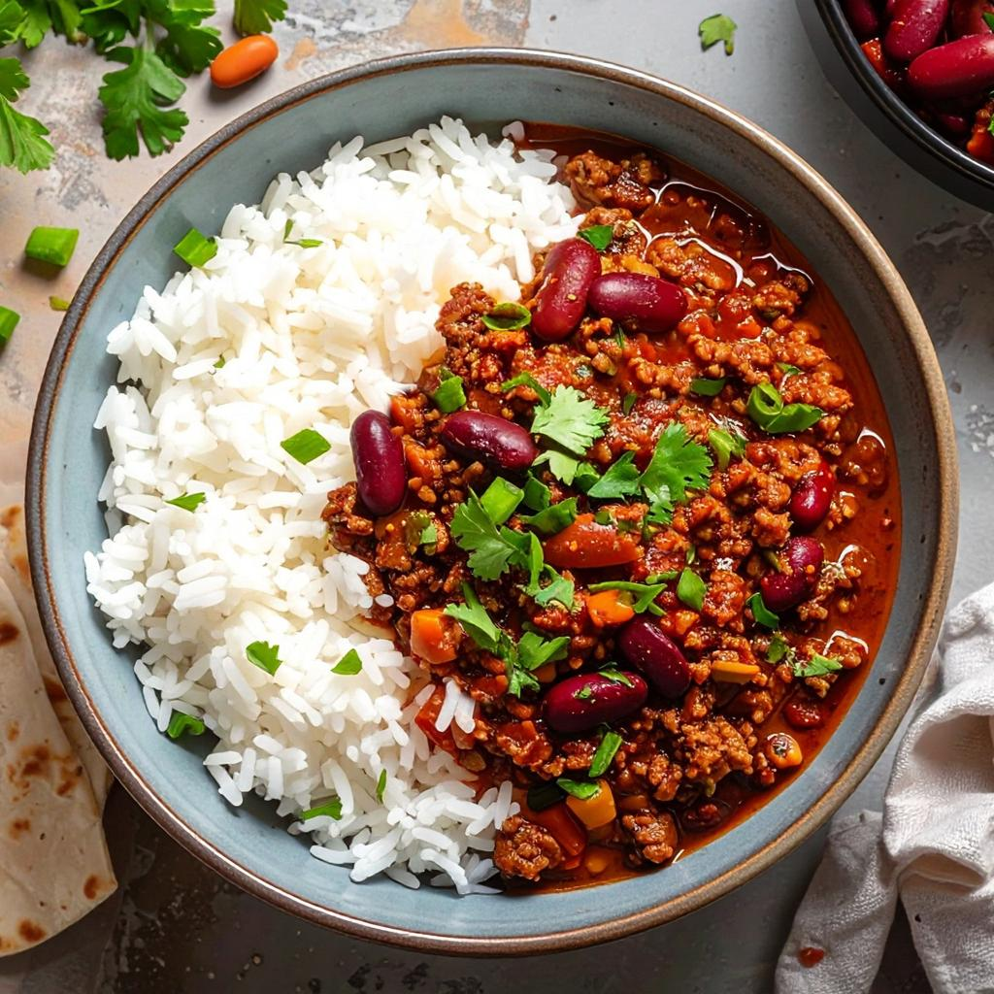
Turkey Chili Rice Bowl
Turkey, kidney beans, rice, tomatoes, choose your vegetable
Protein · Iron · Zinc · Carbohydrates · Vitamin C . Folate
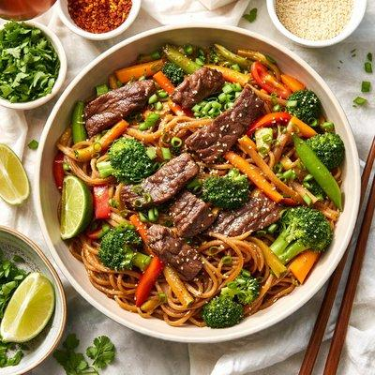
Beef & Broccoli with Noodles
Beef strips, whole-wheat noodles, frozen broccoli, carrots, and peppers
Protein · Iron · Zinc · Vitamin B12 · Carbohydrates · Vitamin C
For when you barely feel like cooking dinner
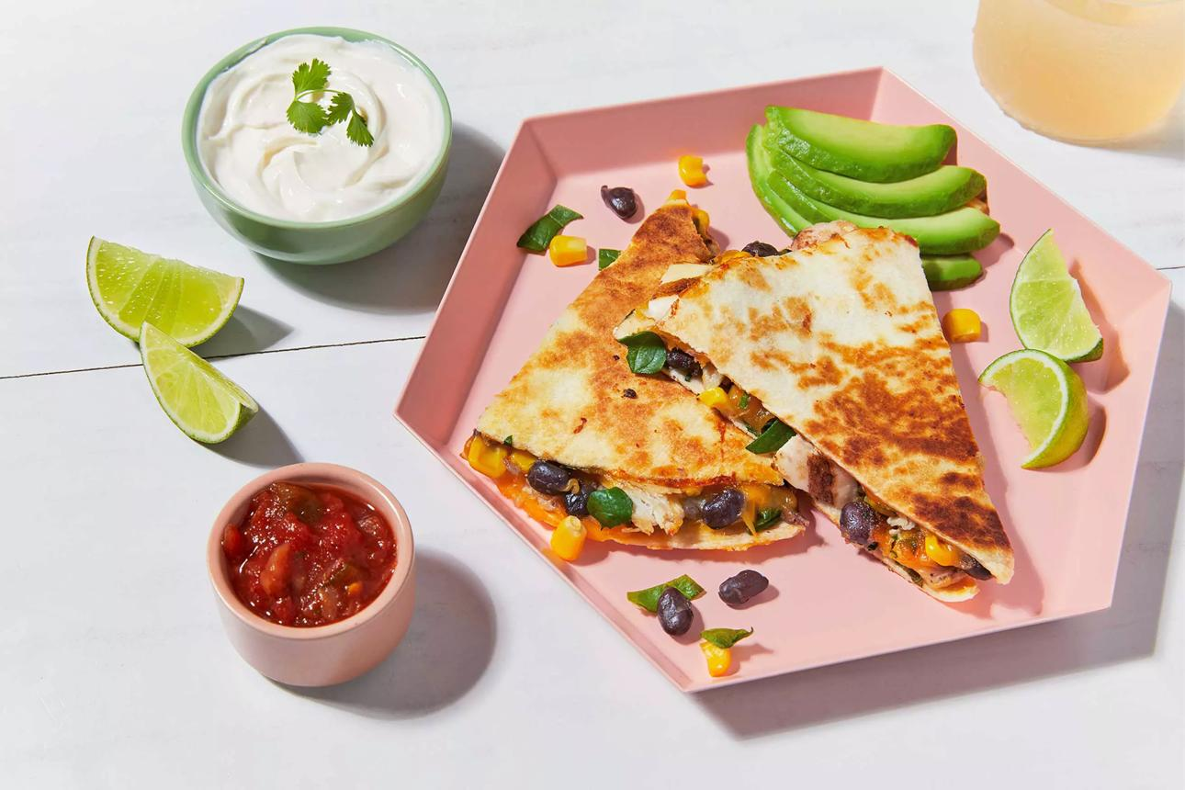
Chicken & Black Bean Quesadilla
Whole-wheat tortilla filled with precooked chicken, black beans, shredded cheese and spinach. Served with a small bowl of salsa and avocado.
Protein · Carbohydrates · Iron · Folate · Zinc · B12

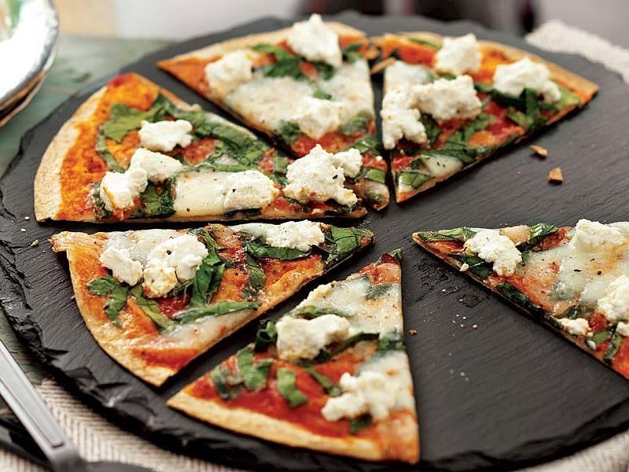
Spinach & Cheese Tortilla Pizza
Whole-wheat tortilla topped with tomato sauce, mozzarella, fresh spinach
Protein · Carbohydrates · Vitamin B12 · Folate · Vitamin C

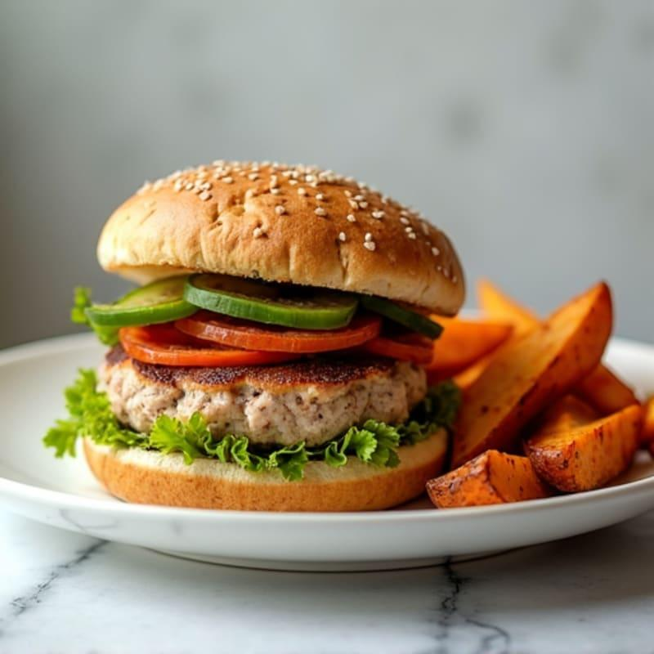
Turkey Burger & Sweet Potato Wedges
Turkey patty, whole-grain bun, lettuce, tomato, roasted sweet potatoes
Protein · Carbohydrates · Zinc · Iron · Vitamin C

For when you have time to make dinner
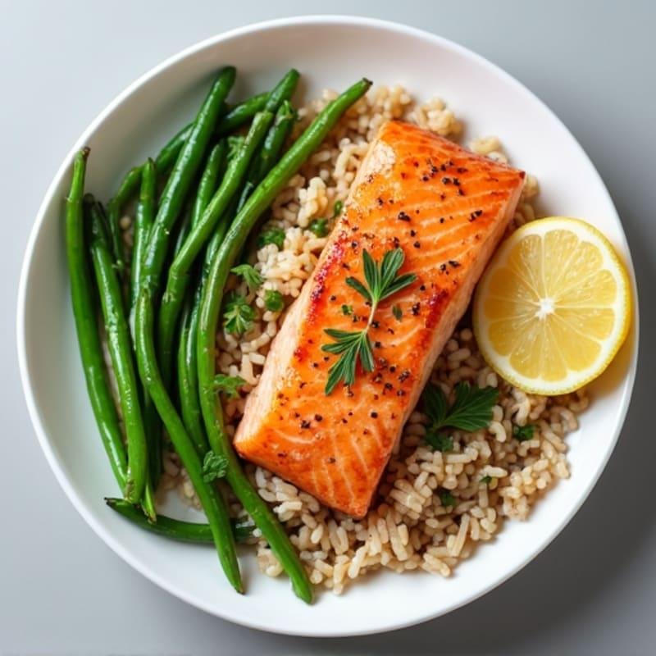
Sweet Thai Chilli Salmon with Rice & Green Beans
Salmon glazed with sweet thai chili sauce, seasoned rice with kidney beans and green beans.
Protein · Carbohydrates ·Vitamin B12 · Omega-3 (EPA/DHA) ·

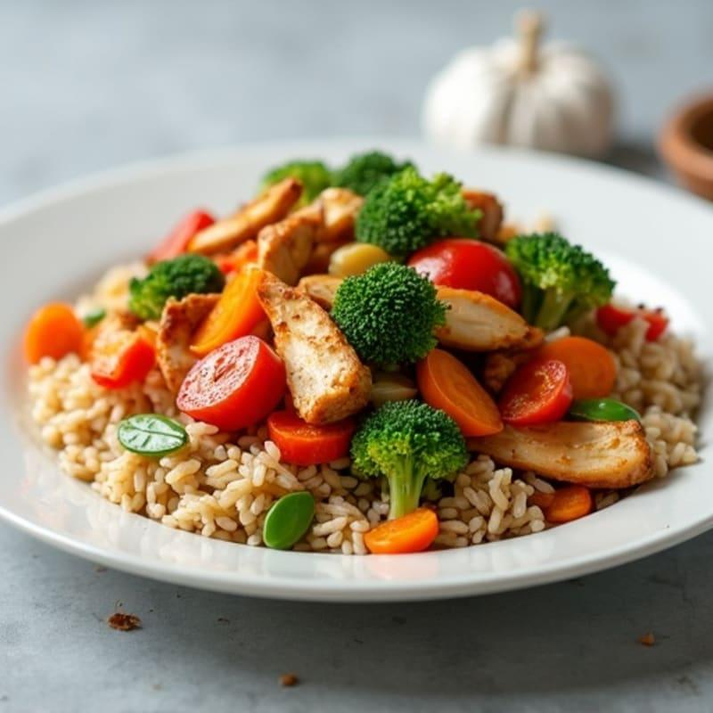
Chicken Veggie Stir-Fry
Chicken, fresh broccoli, peppers, carrots, rice
Protein · Carbohydrates · Vitamin C · Folate

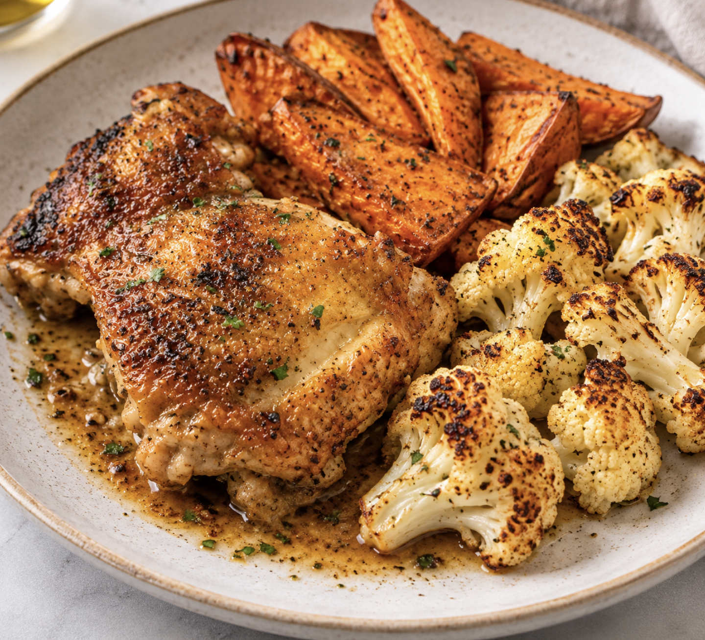
Garlic Chicken with Roasted Sweet Potatoes & Cauliflower
Chicken thighs, sweet potatoes, cauliflower
Protein · Carbohydrates · Vitamin C · Vitamin B12 · Zinc

For when you need a snack between meals
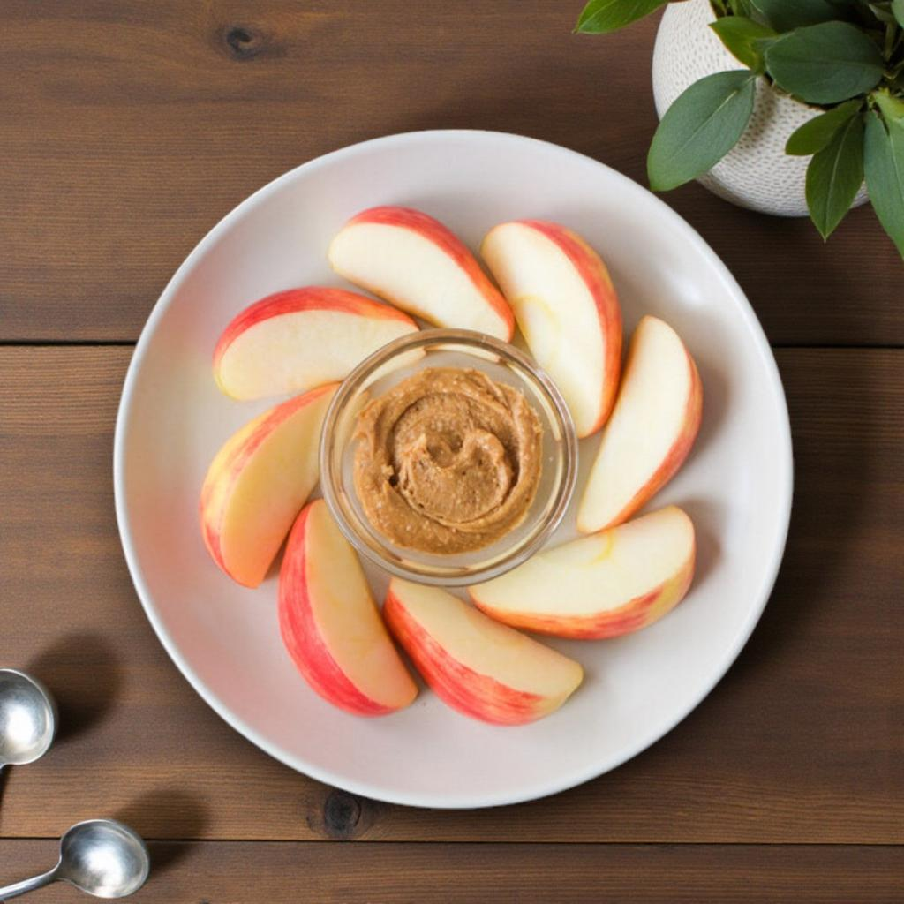
Apple + Peanut Butter
Carbohydrates · Protein
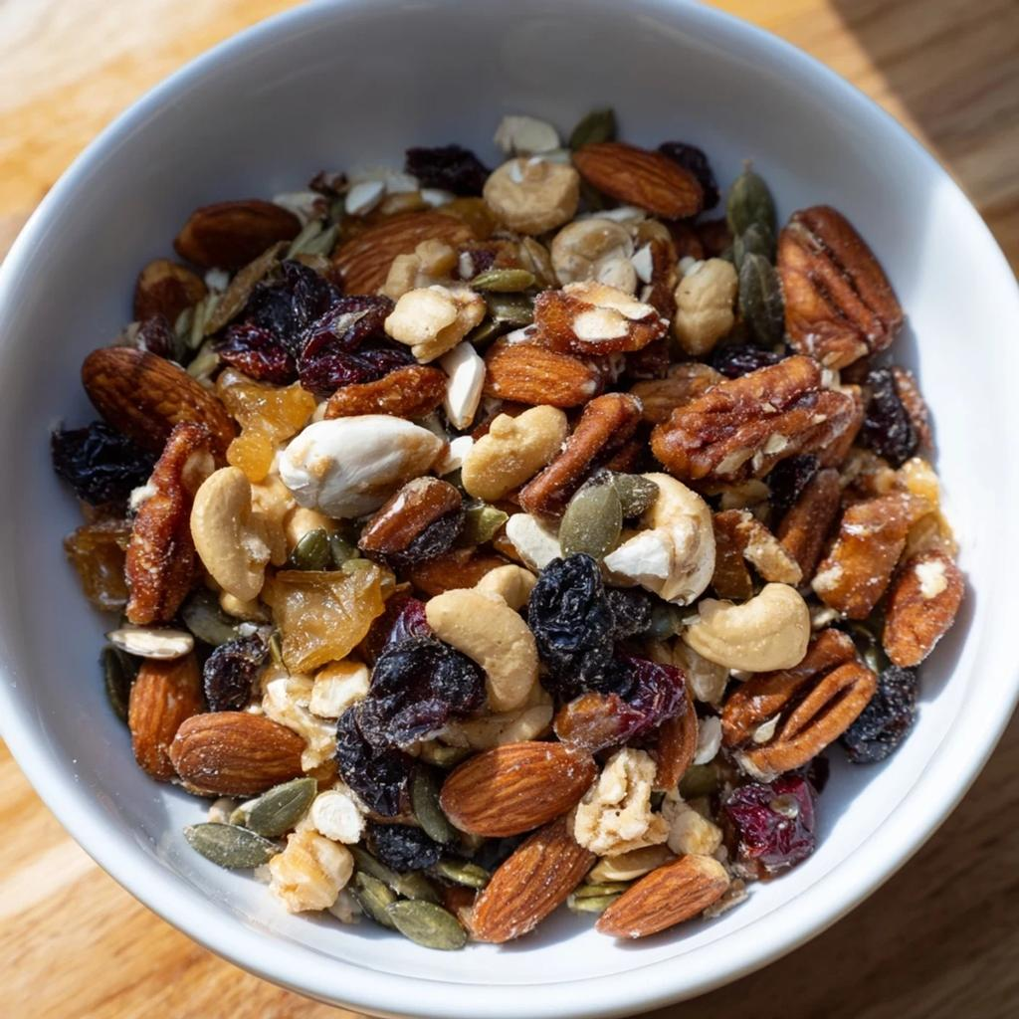
Walnut Cashew & Pumpkin Seed Trail Mix
Omega-3 (ALA) · Zinc · Carbohydrates . Protein

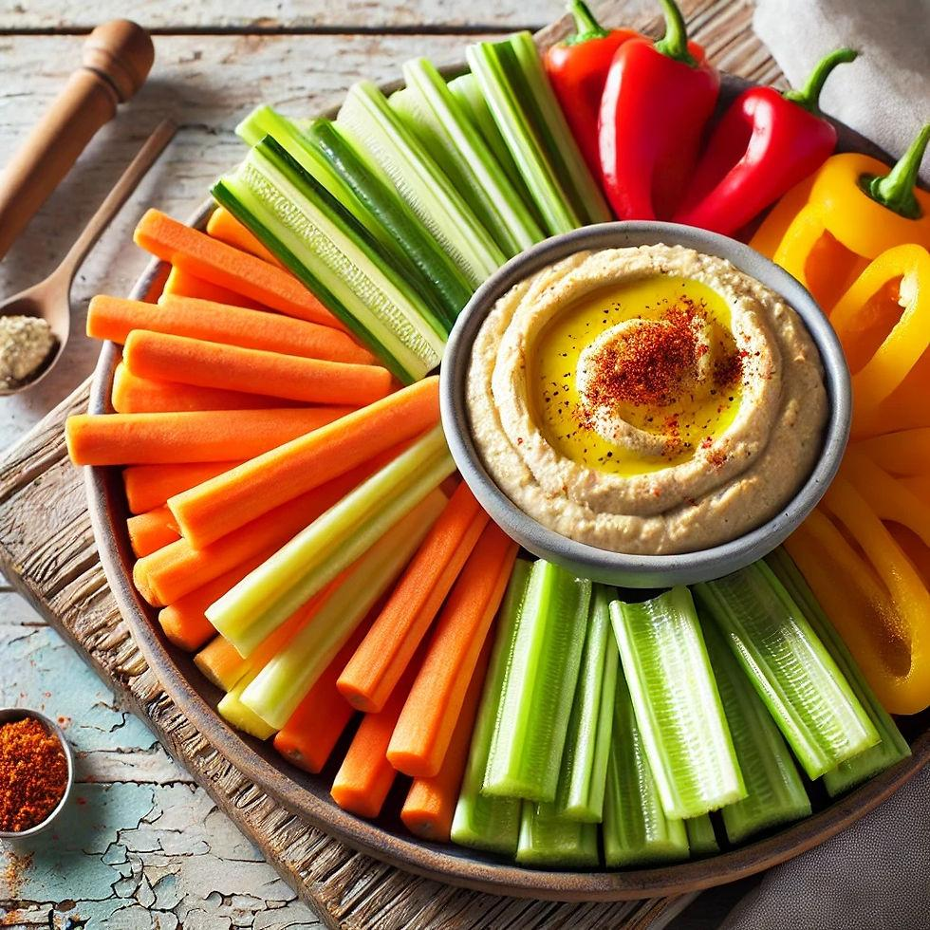
Hummus + vegetable sticks (carrots, celery, bell peppers)
Protein, Carbohydrates, Iron, vitamin C

For the ending, after the meals:
Keep It Simple. Keep It Flexible.
Supporting your hair through nutrition isn't about eating perfectly or following a meal plan down to the last detail.
It's about finding ways to include nourishing foods consistently, in a way that works for your life.
Start with a few meals that sound good to you. Repeat them, change them up, and build a rotation you enjoy.
Small, consistent choices can help you build a stronger nutrition foundation over time.

Some notes:
The vitamin D asterisk: Vitamin D content depends on the type and fortification of milk or milk alternatives used. Check the product label.
add a short statement that the nutrient highlights identify foods contributing those nutrients, not guaranteed amounts or correction of deficiencies.
add a brief disclaimer, ideally on the introductory pages, that these meals support overall nutrition and aren't intended to diagnose, treat, or reverse hair loss

